Destiny McClain

Professor Michael Spivey

COGS 104

10 February 2020

Assignment 1: “Garbage In, Garbage Out”

1. **Tiny-Baby Attractor Network** : Make a vector of 6 elements and normalize it to sum to 1.0.Make a 'while' loop that subtracts .01 from each element and then normalizes again, until one of the elements reaches .95.*'Plot' the 6 activations over time.

clear

t=0

vector=[1,2,3,4,5,6];

vector=vector/sum(vector)

while max(vector)<0.95

t=t+1;

vector=vector-0.01

vector=vector/sum(vector);

allvector(t,:)=vector;

end

plot(allvector)

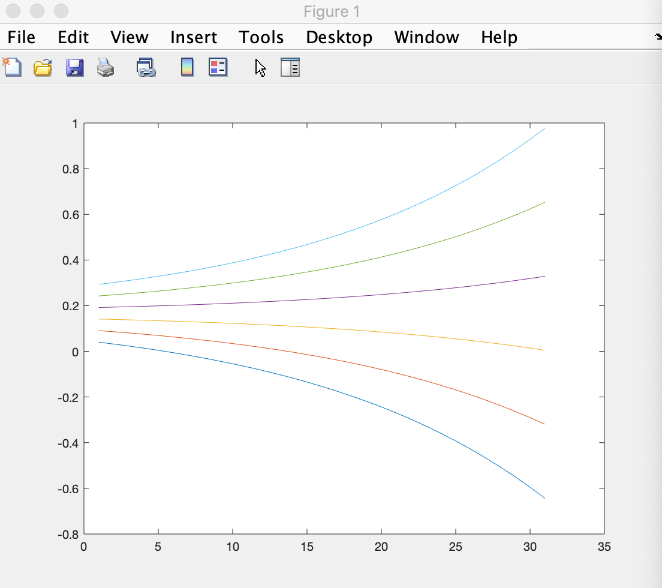

1. **Tiny-Baby Feedforward Network** : Make an 8X4 network (8 inputs, 4 outputs) with fixed random weights between -5 and +5. (we will not train them)Use a 'for' loop to input a random 8-element vector into the network ten times.Have a matrix accumulate the 4-element output vectors.*Do a 'mesh' plot of that matrix.

clear

t=0;

x=rand(8,4)*10-5;

for n=1:10;

t=t+1;

input = rand(1,8);

input*x;

allinput(t,:)=input;

end

plot(allinput)

